Handout 1: Maps
Map 1: Lee’s Confederate troop positions at Cold Harbor are shown in grey on this map. Grant’s Union troops are shown in blue and are advancing on the Confederate positions. (National Park Service.)
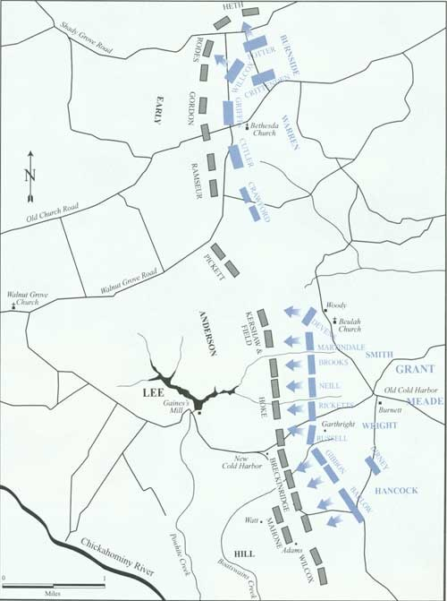
Map 2: The Confederate army positions are shown in red on this map. They are camped to the left of the tree line and field. The Union forces are shown in purple and follow the Cold Harbor road. (Sneden, Robert Knox. Plan of Battle of Cold Harbor, Va.: June 1st and 3rd 1864. Library of Congress.)

